Modeling a 3 qubit Linear Optical Quantum Computer to identify and optimize sources of optical loss

Aadittya Tiwari¹
1. Department of Electrical & Computer Engineering, Georgia Institute of Technology, Atlanta, GA, USA.

Abstract
Optical systems are a promising platform for quantum computation, but one of the engineering constraints that hinders development of the field is optical loss within linear optical quantum computers (LOQC). LOQC systems use photons to serve as the qubit source, and optical components such as beamsplitters and wave plates to apply quantum logic gates. Optical loss contributes to the decoherence of quantum states in an LOQC and incorrect attenuation ratios for beamsplitters, which physicists aim to control. Optical loss can arise from several sources, including but not limited to: waveguide scattering after propagation, material properties of optical components, and the physical organization of these components. This work recreates a three qubit LOQC in COMSOL, a finite element analysis solver, and performs a multivariable parameter sweep over a loss function that we aim to minimize in order to find potential configurations of the optical components and materials to minimize loss within the LOQC. Results quantify the performance of individual parameter configurations in meeting target values for power retention and beamsplitter attenuation requirements in an interferometric control-Z gate operation.

Keywords: Linear Optical Quantum Computing (LOQC), Optical Loss Optimization, Digital Twin Design, Beam Envelopes Method (EWBE).

Introduction

Quantum Computing is an active field of research because of its potential to enable key breakthroughs in fields such as cryptography (via Shor’s algorithm for prime number factoring, relevant to RSA encryption) [1], pharmaceutical drug discovery (via quantum eigensolvers for molecular modeling) [2], and machine learning (via variational quantum circuits for neural network optimization) [3], with additional research in finding more problems with potential quantum solutions. In order to realize these solutions, sufficient hardware is required. For a system to be classified as a fault tolerant quantum computer, it needs to meet DiVincenzo’s criteria [4]. These criteria dictate that a quantum computer must be able to: 1. Consist of a scalable amount of characterizable quantum bits (qubits), particles whose behavior is determined by quantum mechanical processes. 2. Initialize all bits in a system to an initial (fiduciary) value, i.e. all 0’s. 3. Maintain long decoherence times relative to gate operation times, such that qubits can maintain relevant quantum physical properties during algorithm execution. 4. Perform a universal set of quantum gates, the operations that affect the probabilities of a qubit measuring either a 0 or 1 state. 5. Measure the value of the qubits in the system. Notably, none of these requirements dictate a certain platform for achieving these criteria is necessary to assemble a quantum computer. As a result, research institutions and startups have researched several differing platforms for quantum computing hardware have emerged, including trapped ions, neutral atoms, superconducting atoms, and photonic platforms as possible contenders to develop a system that meets DiVincenzo’s criteria. Photonic platforms are of particular interest, because unlike the aforementioned approaches, 1. Photons are inherently immune to decoherence from a noisy environment and do not require < 1 milliKelvin temperatures to maintain coherence. 2. Photonics and Optoelectronics is an already well-developed field of research, facilitating the proliferation of bulk optical components required to perform optical quantum computing.
However, as a result of photons being naturally immune to interference, multi qubit quantum logic gates that rely on intra-system interference are nearly impossible to implement. Non-linear optical effects can be utilized to perform these gates, but non-linear media are inherently lossy systems, ultimately making them impractical to be used within systems that require the persistence of single photons throughout an entire optical system. This challenge was overcome by the introduction of the KLM protocol [5], which enabled the construction of multi qubit gates using strictly linear materials. The KLM protocol led to the proliferation of Linear Optical Quantum Computing (LOQC) research as a viable platform to implement fault tolerant quantum computation. Because of its compatibility with existing mass manufactured bulk optic components, LOQC is a favorable platform for budget constrained demonstrations of quantum computing. However, linear entangling gates come with the tradeoff of losing 8/9 photons sent through the system. An active field of research within LOQC remains the optimization of the loss within optical setups. Careful manipulation of optical loss is important for the retention of individual photons after gate operation and maintaining specific beamsplitter attenuation ratios to perform interferometric entangling gates. This paper aims to recreate an LOQC system within COMSOL in order to observe how changing the photon’s wavelength and beamwidth relative to the wavelength the polarizing beamsplitters (PBSs), beamsplitters, and anti-reflection coating were designed around, the organizational distance between the components in the system, and the environmental temperature’s impact on refractive indices, impact the loss of photons within the system.

Theory / Experimental Set Up
This model is intended to simulate a three qubit LOQC, with a universal set of single qubit logic gates being applied to the first qubit and a CZ gate being applied to the second and third qubits. Single qubit logic gates are implemented using half wave plates and quarter wave plates. The implementation of the CZ gate implemented in this paper will be done by implementing an interferometric approach described in the referenced papers [6,7]. The setup contains two single photon sources, four polarizing beamsplitters, three partial non-polarizing beamsplitters, and two photon detectors. The aim of this paper is to perform a study on the loss occurring within the CZ gate rather than photon generation and measurement. Consequently, the model will fully recreate the polarizing and non-polarizing beamsplitter arrangement while abstracting away the photon sources and measurements to gaussian beam power sources using boundary integration operations.
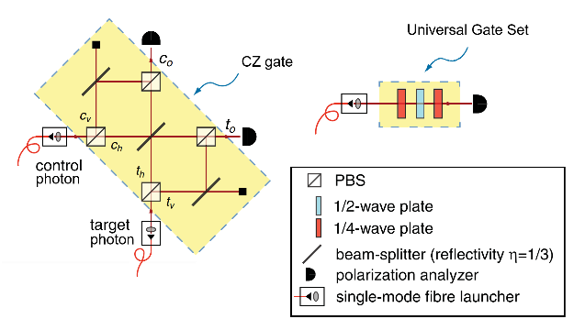
Figure 1. The optical tabletop setup of a CZ gate on two qubits and universal gateset on a third.
The effect of the CZ gate on the control and target photon is to implement the transformation:

$α|HHi + β|HV i + γ|V Hi + δ|V V i → 1 3 [-α|HHi+β|HV i+γ|V Hi+δ|V V i]+...,$

where H and V refer to horizontal and vertical polarization, and the terms not shown correspond to the failure mode of the gate (i.e., the control and target output ports do not each contain one photon). It is important to note that ⅓ reflecting beamsplitters are used in order to accurately match the probability amplitudes of measuring any of the four possible output combinations. For that reason, this gate has a theoretical 1/9 success rate under perfect conditions, as two qubits will only be reflected into both photodetectors in ⅓ * ⅓ cases. The effect of the quarter-half-quarter waveplate sequence is to implement the equation

$QWP\left(θ_{3}\right)*HWP\left(θ_{2}\right)*QWP\left(θ_{1}\right)*{\left|ψ\right\rangle }_{in}=U\left(θ_{1},θ_{2},θ_{3}\right)*{\left|ψ\right\rangle }_{in}={\left|ψ\right\rangle }_{out}$

Where the waveplate Jones Calculus representations are:

$$HWP\left(θ\right)=\left[\begin{matrix}\cos\left(2*θ\right) & sin⁡(2*θ) \\ sin⁡(2*θ) & -cos⁡(2*θ)\end{matrix}\right]$$
$$QWP\left(θ\right)=\left[\begin{matrix}\cos^{2}{θ+i*\sin^{2}{θ}} & \left(1-i\right)*\sin{θ}*cos⁡(θ) \\ \left(1-i\right)*\sin\left(θ\right)*cos⁡(θ) & \sin^{2}{θ+i*\cos^{2}{θ}}\end{matrix}\right]$$

Deviations from the ideal conditions assumed by these setups will lead to inaccurate mathematical operations on the photonic. The deviations this model explores are from refractive index changes because of environmental temperature change, design wavelength and beam width deviations from imperfect laser design specs, and effects of propagation distance changes.

Governing Equations / Numerical Model / Simulation / Methods / Use of Simulation Apps

Geometry
As a beam is axisymmetric, we can simplify modeling by building our model in two dimensions instead of three. The geometry of the Polarizing Beamsplitter is obtained from the Polarizing Beamsplitter model app [8]. The input parameters for the Polarizing Beamsplitter app were a center wavelength of 900nm, bandwidth of 400nm, and thin film layer count of 7, to match with commercially available PBSs. In commercial PBSs, the thin film layer count would be much higher, but for our simulation purposes 7 is enough to reach realistic reflection and transmission coefficients while keeping model mesh requirements manageable. Air domains are defined as rectangles with the same width/height as the beamsplitters and height/width of ‘air_domain_length’, one of the variables to be swept to control the beam's air domain propagation length. The partial beamsplitter’s thin film is implemented by a transition boundary condition applied to a 1-dimensional line drawn across beamsplitter square’s vertices. Perfectly Matched Layer domains are defined as rectangles adjacent to air domains with a thickness of 2nm.

Physics Package
To simulate wave optics, the choice of package is the Electromagnetic Waves, Beam Envelopes (EWBE) module. The more robust Electromagnetic Waves, Frequency Domain (EWFD) package was considered as it would be able to represent multiple beam propagations with greater accuracy, but ultimately it is limited to domain sizes on the scale of micrometers as a result of the sub-wavelength meshing requirements. This makes it incompatible with simulations requiring total domain area on the scale of centimeters, such as this one. The EWBE has significantly less computational requirements while maintaining similarly accurate results, under the condition of the waves propagating with well-defined bi-directionality or uni-directionality, which applies to our case. However, this means back reflections as a result of light propagating between two domains of differing refractive indices are incorrectly represented. Antireflection coatings are applied on the interfaces of all beamsplitter prisms in order to minimize the effect of back reflections, allowing us to continue usage of the EWBE package.

Material Assignment

The prisms of the Polarizing Beamsplitter are assigned SF5 glass. The high index thin film layers are assigned Zinc Sulfide (ZnS). The low index thin film layers are assigned Magnesium Fluoride (MgF2). The silver thin film of the partial beamsplitter is assigned Silver (Ag). The air domains are, obviously, assigned air.

As the careful selection of refractive indices in the polarizing beamsplitter is what ultimately determines PBS efficiency, a change of temperature can lead to a change in refractive indices which lead to reduced polarization separation efficiency. Similarly, the attenuation coefficient of a beamsplitter is heavily dependent on the refractive index of the thin film within it, meaning if the temperature changes the refractive index of that thin film, there will be deviations in attenuation coefficient. In order to model the effects of temperature on the refractive indices of these materials, the refractive indices of all materials are calculated using thermo-optic Sellmeier equation, except air, which is highly accurately modeled as n=1 in our conditions.

$$n^{2}\left(λ,T\right)=\sum_{n=1}^{3}{\frac{B_{j}\left(T\right)λ^{2}}{λ^{2}-C_{j}(T)}}$$

The optical and thermal coefficients are taken from papers which obtained experimental values for the refractive indices of these materials at various wavelengths and temperatures to determine the coefficients [9,10,11,12]. Because the silver thin film is significantly thin and must be accounted for by experimentally obtaining values at that specific thickness, values for the thermo-optic Sellmeier equation are difficult to come across. For this reason, the closest experimental data obtainable was a Drude-Lorentz Equation for Silver of 34 nanometer thickness, and the refractive index and extinction coefficient for our silver thin film is derived by taking the real and imaginary components of the square root of the Drude-Lorentz equation as follows.

$$ϵ\left(ω\right)=ϵ_{∞}+\frac{ω_{p}^{2}}{ϵ^{2}+iΓ_{D}ω}+\frac{A_{1}}{E_{1}^{2}-{\left(ℏω\right)}^{2}-iγ_{1}(ℏω)}$$
$$n+ik=Re\left(ϵ\left(ω\right)\right)+i*Im(ϵ\left(ω\right))$$

Boundary Conditions
Gaussian beam sources are implemented using Matched Boundary Conditions, defining gaussian beam parameters in the gaussian beam equation. Photon detection is represented using Matched Boundary Condition for Waves 1 and 2 for the Target and Control qubit. To launch linear 45 degree polarized light, the Incident Electric Field Envelope input parameters for source 1 are:
$${E_{x}}_{1}=0$$
$${E_{y}}_{1}=E_{z_{1}}=E_{0}*e^{{\left(-\frac{y}{w_{0}}\right)}^{2}}$$
For source 2, they are:
$${E_{x}}_{2}=E_{z_{2}}=E_{0}*e^{-{\left(\frac{x-a-adl}{w_{0}}\right)}^{2}}$$
$$E_{y_{2}}=0$$
X and Y are cartesian co-ordinates that increase as the beam propagate. ‘a’ is the variable name for the length of the beamsplitter edges. ‘adl’ is the parameter swept variable for the Air Domain Length. These co ordinate offsets are added to the exponential term to account for the physical co ordinates of the beam sources such that the strength is maximum at the source.
When propagating within air, edges where scattered light may reach need to be defined as infinitely continuous domains such that light does not inaccurately reflect back into the system at the physical edges of the air domain geometry. In order to do this, a combination of Perfectly Matched Layers (PMLs) and Scattering Boundary Conditions (SBCs) are used. While PMLs are much more efficient at dissipating light, it requires a physical domain to perfectly line up with the boundary it is covering. This becomes problematic in cross shaped regions in our model, where it is impossible to have two rectangles cover a cross region without intersection, which would lead to model inaccuracies. Therefore, as many PMLs were defined as possible without intersections between any two, and any remaining regions were sufficiently modeled using SBCs. To represent photodetectors, Matched Boundary Conditions (MBCs) were used with their input parameters set to the first and second wave respectively of the qubit it was associated with. To represent the partially reflecting beamsplitter’s silver thin film, a Transition Boundary Condition (TBC) is assigned to a line cutting through a square domain. The thickness of the thin film is 7 nm. To represent antireflection coatings, a TBC is assigned between any interface where the refractive index changes. The refractive index of the TBC and its thickness are defined as follows to implement antireflection coating:

$$n_{antireflection}=\sqrt{n_{air}}$$
$$d_{antireflection}=\frac{800nm}{4*n_{antireflection}}$$

800 nanometers is chosen as the design wavelength of the system’s simple one layer antireflection coating.

Mesh
The mesh for all rectangular regions is defined by a Mapped mesh in order to use rectangular mesh elements. Triangular prisms are defined by the Free Triangular mesh. Maximum element size is one quarter the beam width, minimum element size is 2.65E-5 mm from the default configuration for fine mesh. For the Perfectly Matched Layers, we utilize the Mapped mesh’s distribution feature to ensure that the PMLs contain 5 mesh elements of depth for efficient beam dissipation.

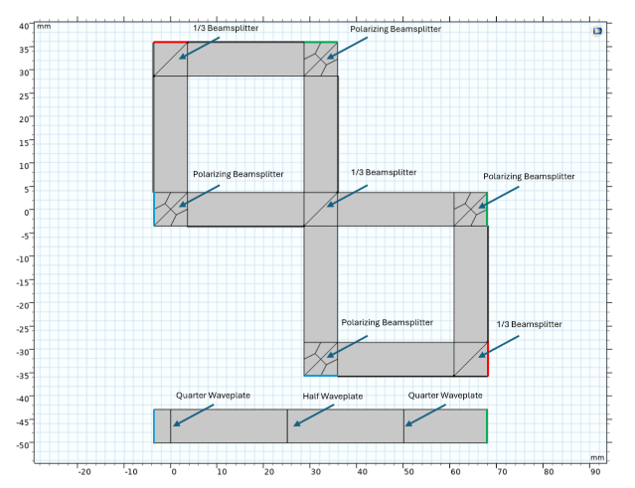
Figure 2. The annotated COMSOL setup of a CZ gate on two qubits and universal gateset on a third.
Parameter Sweep
The following table details the variables being swept and their sweep range. The first entry in a range is the minimum value, the second is increment, third is maximum value.

Variable Name | Range | Units
Wavelength | 790,5,805 | Nanometer
Temperature | 285,5,300 | Kelvin
Beam Waist | 0.9,1.8,2.7 | Meter
Air Domain Length | 25,25,75 | Millimeter

Simulation Results / Discussion
Integration operations (IntOps) are used to measure the power of light reaching a domain boundary. IntOps are calculated for the two power sources, two beamsplitter attenuation boundaries, and two control gate measurement boundaries. With these six quantities, we are able to calculate the attenuation coefficient for each beamsplitter, the proportion of light that makes it to the single photon detectors, and the proportion of light that is accounted for, meaning the sum of all detection sources and dumps divided by the total launched power. These are the metrics by which performance of the system is quantified. These values are calculated for each of the parameter sweep configurations, and plotted in the following figures.
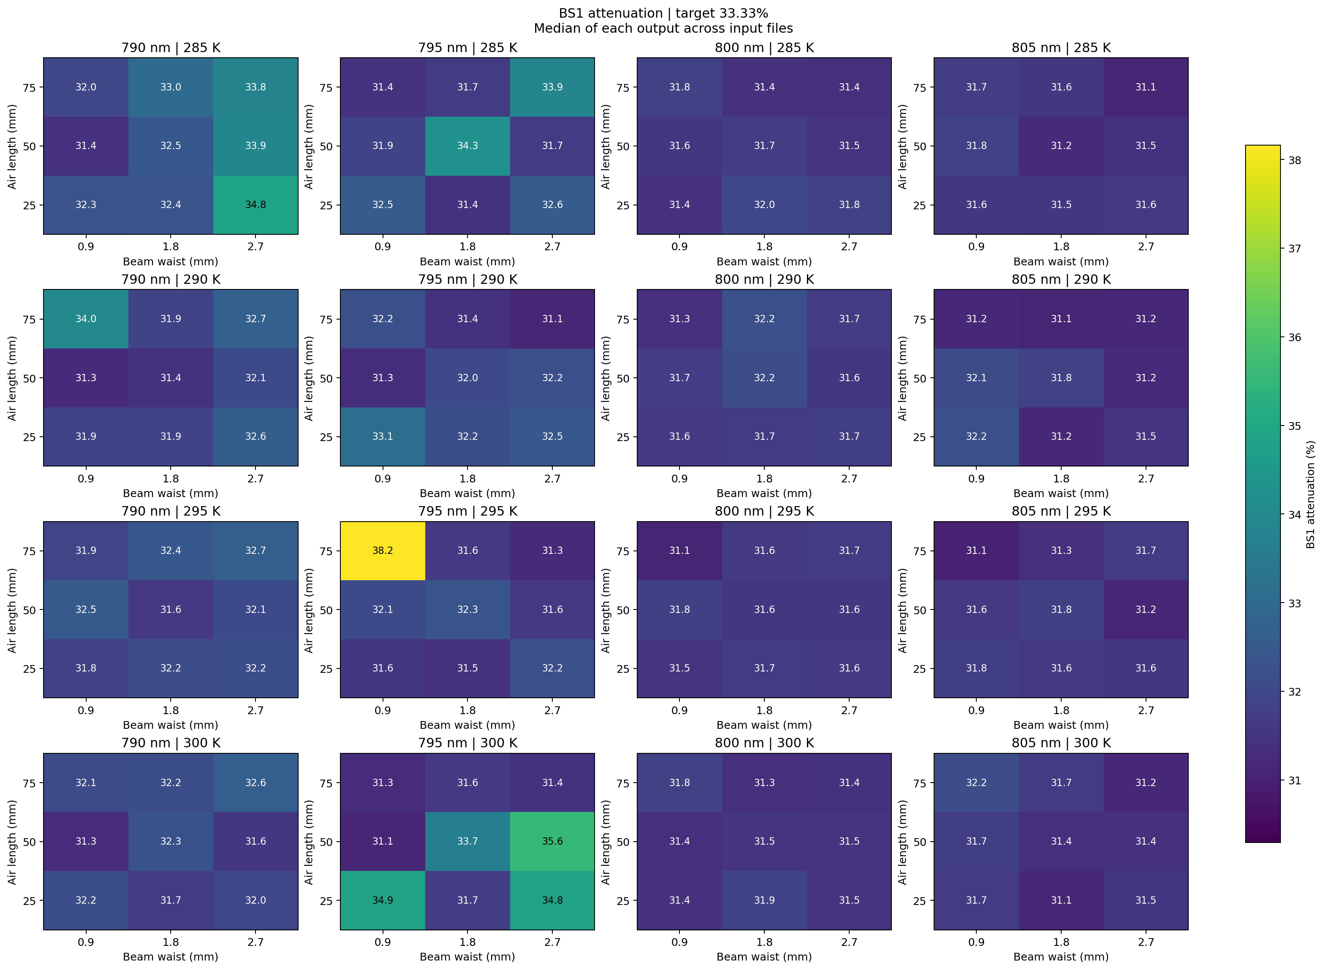
Figure 3. Heatmap depicting proportion of reflected light from top left beamsplitter. Target value = 1/3.
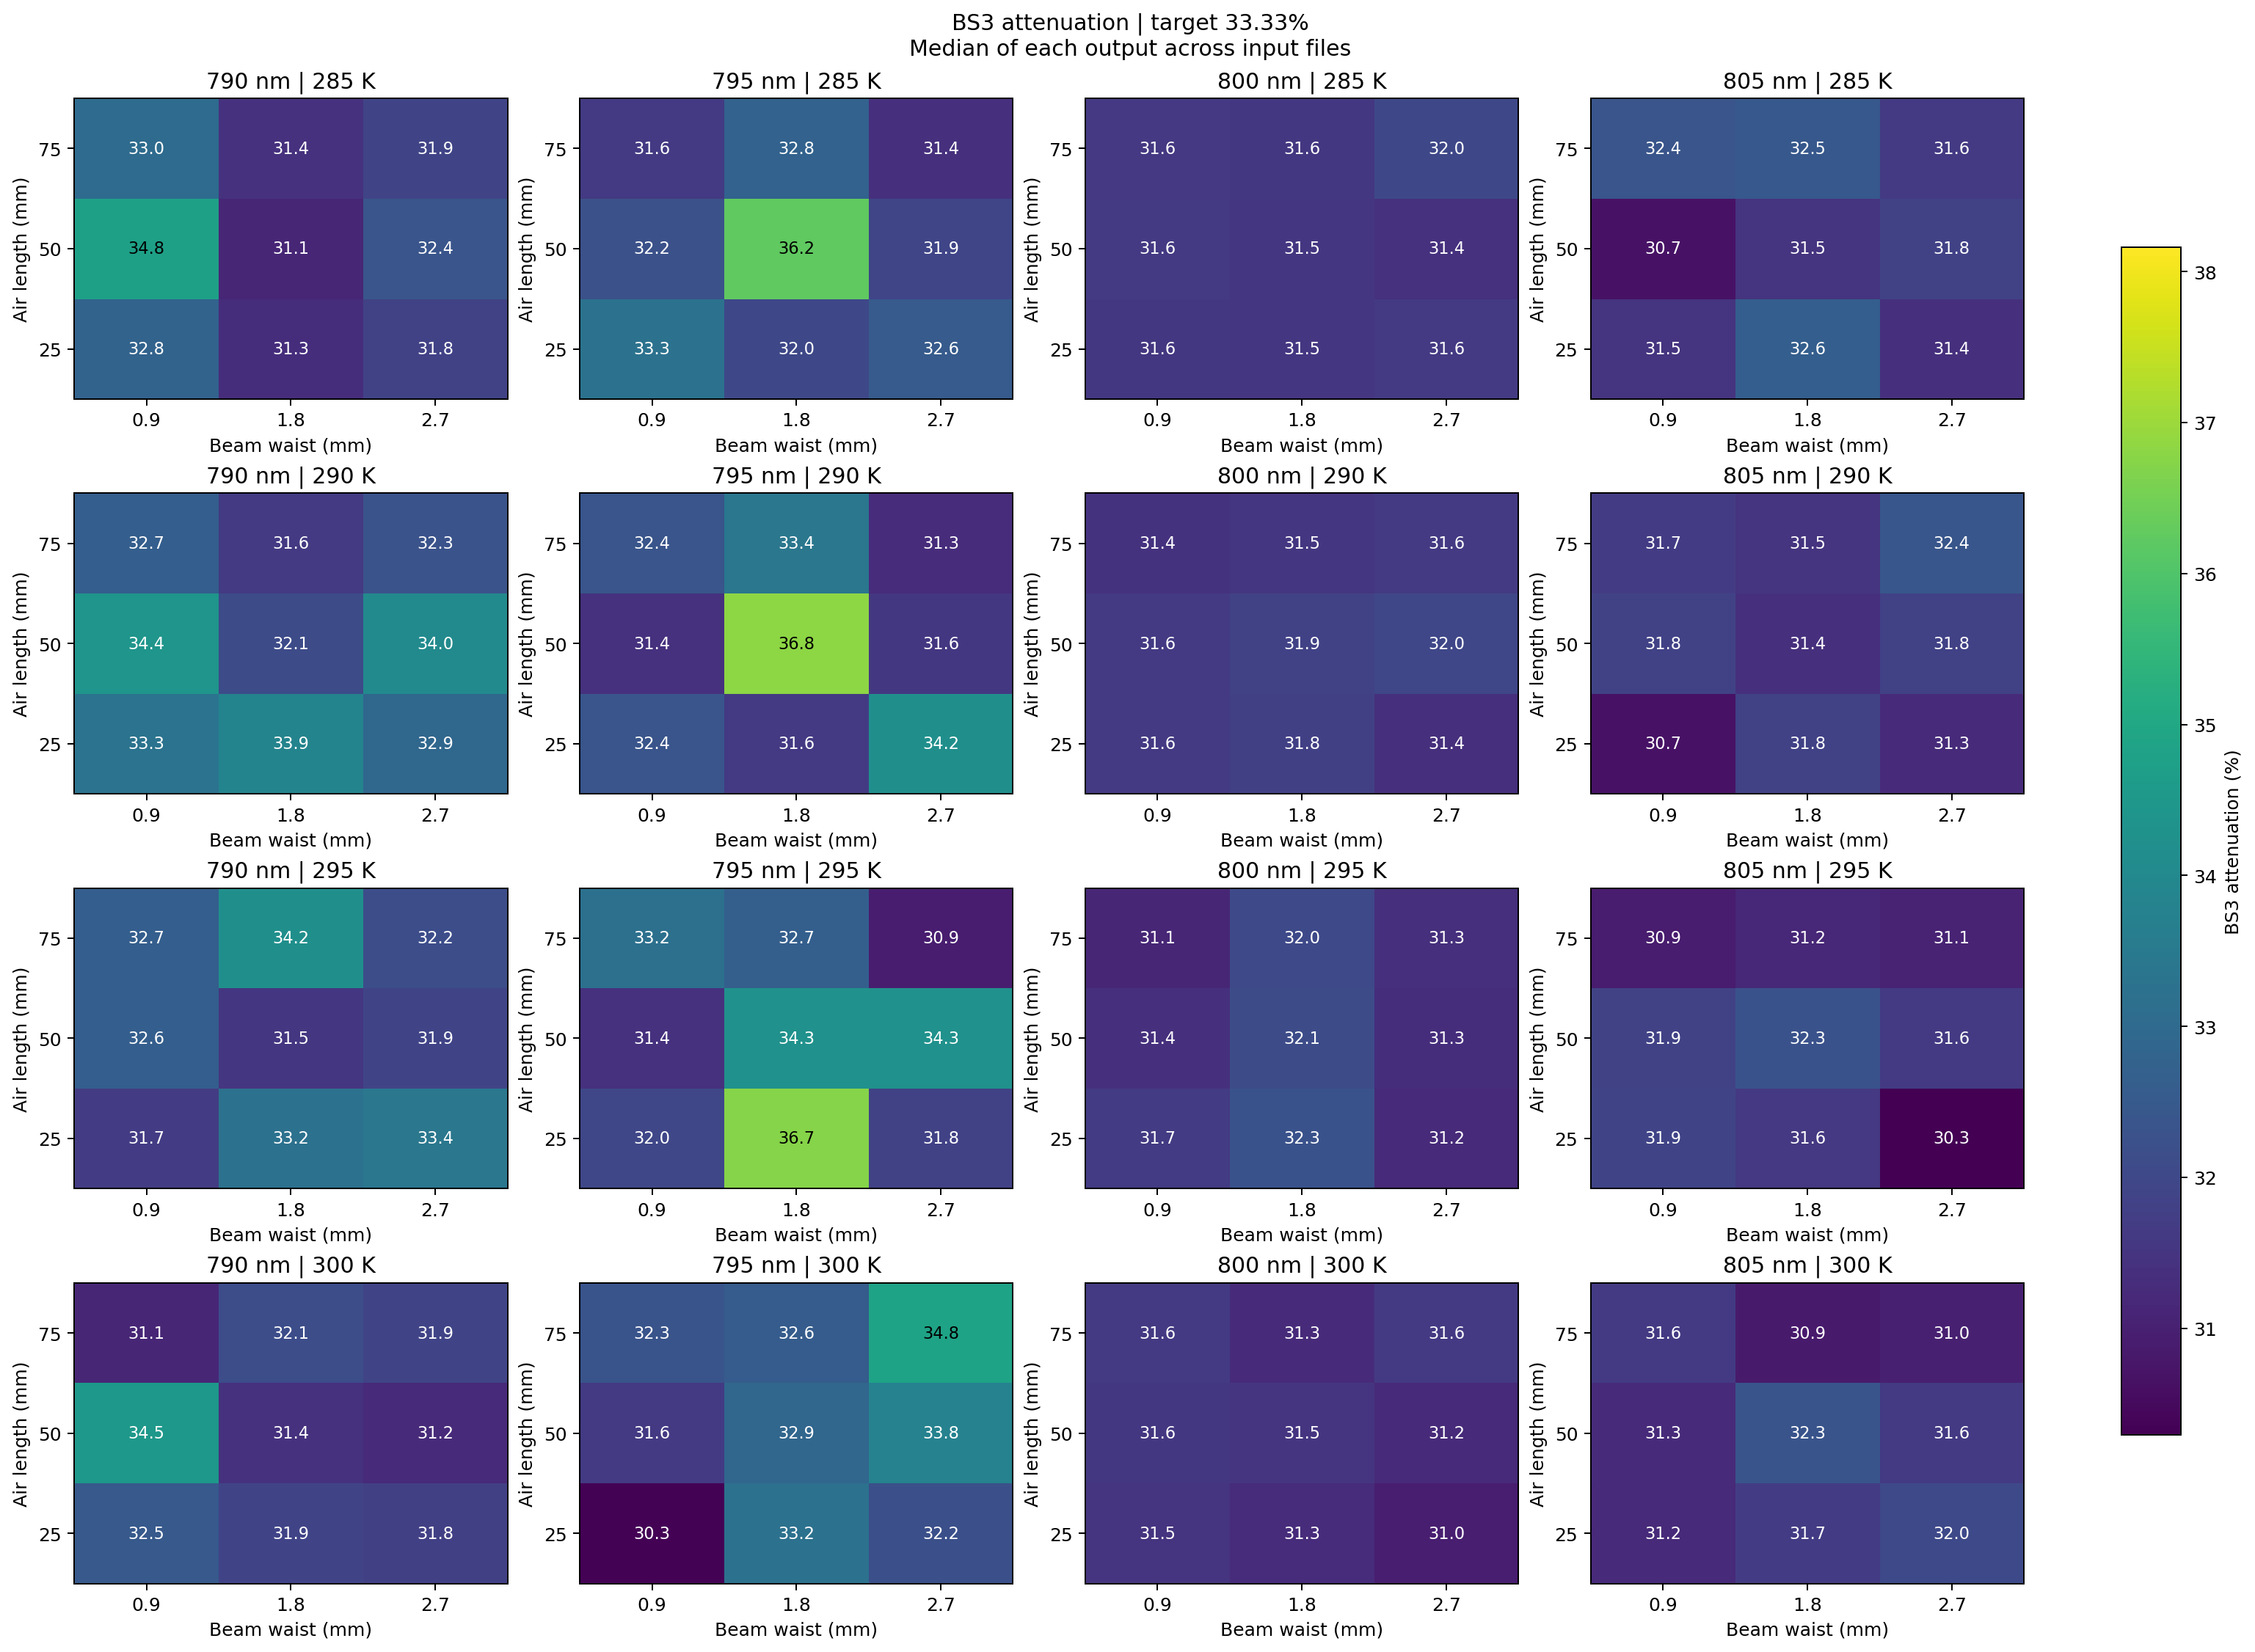
Figure 4. Heatmap depicting proportion of reflected light from bottom right beamsplitter. Target value = 1/3.
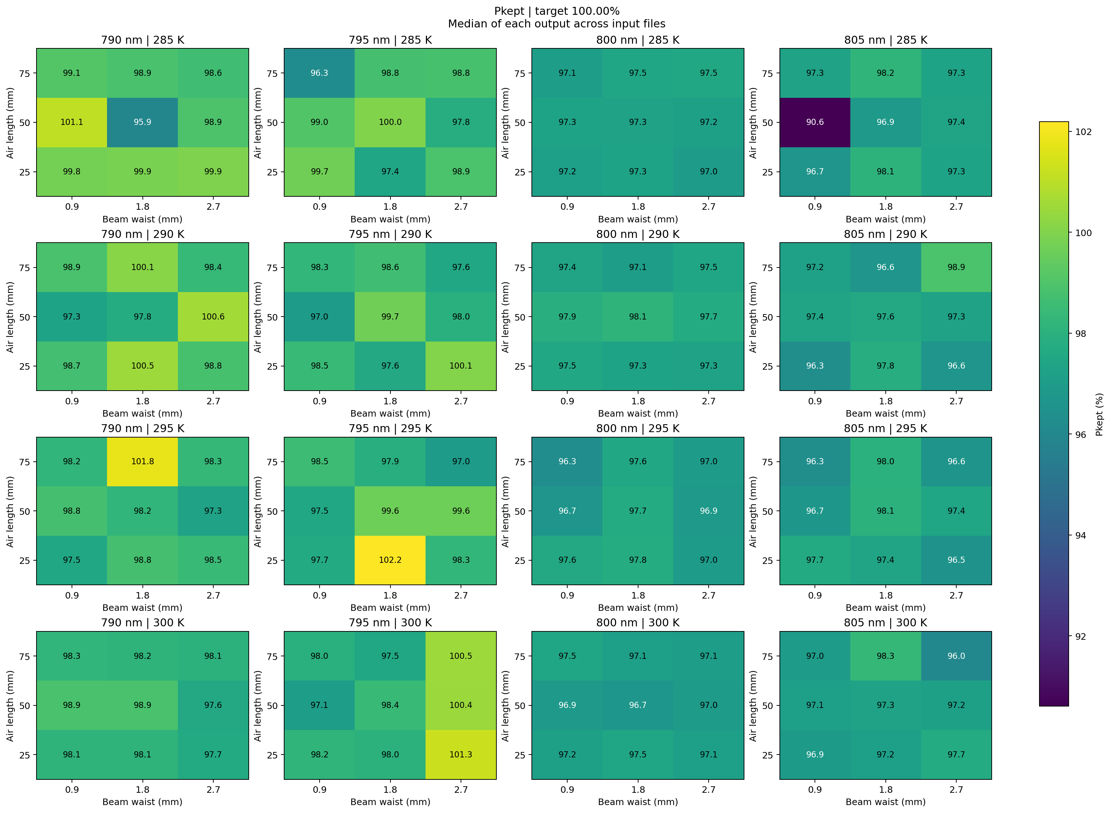
Figure 5. Heatmap depicting proportion Power measured at output relative to Power input. Target value = 1.

Conclusions and Future Work
Our results help visualize the gradient of performance changes of the LOQC as each parameter is changed by a small amount. This sheds light on the incredible sensitivity of even small scale LOQC’s to the configuration of experimental parameters, quantifying the effect an error may have on performance. The results could be of use when given certain measurements characterizing a LOQC’s performance using the metrics we defined to determine which set of parameters could potentially be used by your system rather than its presumed ideal parameters.

Future work could include an analysis of larger scale quantum operations within a more compact Silicon Photonics chip, on the order of tens of gate operations per qubit. This would provide insight to more practically applicable circuits that may be found more commonly in industry as optical quantum computing moves towards foundry manufacturing for the bulk production of chiplets. The sourcing of more accurate general thermo-optic Sellmeier equations would also be of interest, although most Sellmeier equations for thin film cases need to be individually characterized on account of non-negligible case-by-case imperfections within thin films. More effective modeling of photon propagation and specifically the Hong-Ou-Mandel effect could be implemented with the ODE solver rather than approximating a statistically large amount of photons using Gaussian beams.

References

[1] | P. W. Shor, “Polynomial-Time Algorithms for Prime Factorization and Discrete Logarithms on a Quantum Computer”, arXiv preprint, quant-ph/9508027, 1995.
[2] | Y. Cao et al., “Potential of quantum computing for drug discovery”, IBM Journal of Research and Development, vol. 62, no. 6, pp. 6:1–6:20, 2018.
[3] | K. Mitarai et al., “Quantum circuit learning”, Physical Review A, vol. 98, article 032309, 2018.
[4] | D. P. DiVincenzo, “The Physical Implementation of Quantum Computation”, Fortschritte der Physik, vol. 48, pp. 771–783, 2000.
[5] | E. Knill et al., “A scheme for efficient quantum computation with linear optics”, Nature, vol. 409, pp. 46–52, 2001.
[6] | N. K. Langford et al., “Demonstration of a simple entangling optical gate and its use in Bell-state analysis”, Physical Review Letters, vol. 95, article 210504, 2005.
[7] | H. F. Hofmann and S. Takeuchi, “Quantum phase gate for photonic qubits using only beam splitters and post-selection”, Physical Review A, vol. 66, article 024308, 2002.
[8] | COMSOL AB, “Polarizing Beam Splitter”, in COMSOL Multiphysics Application Library, Wave Optics Module, Application ID: 31041.
[9] | SCHOTT AG, “SF5”, in Optical Glass—Datasheet Collection.
[10] | D. Leviton and B. Frey, “Temperature-dependent refractive index of Cleartran® ZnS to cryogenic temperatures”.
[11] | W. J. Tropf, “Temperature-dependent refractive index models for BaF₂, CaF₂, MgF₂, SrF₂, LiF, NaF, KCl, ZnS, and ZnSe”, Optical Engineering, vol. 34, no. 5, pp. 1369–1373, 1995.
[12] | H. Reddy et al., “Temperature-Dependent Optical Properties of Single Crystalline and Polycrystalline Silver Thin Films”, ACS Photonics, vol. 4, no. 5, pp. 1083–1091, 2017.

Acknowledgements
COMSOL Access was provided by the Georgia Tech College of Engineering Virtual Machines. Funding for attending COMSOL proceedings were provided by the Georgia Tech President’s Undergraduate Research Award, Student Government Association, and school of Electrical and Computer Engineering.

